Irradiance Calibrator

TR 6421/001
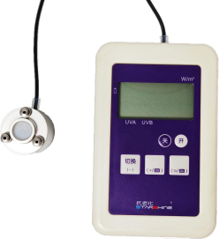

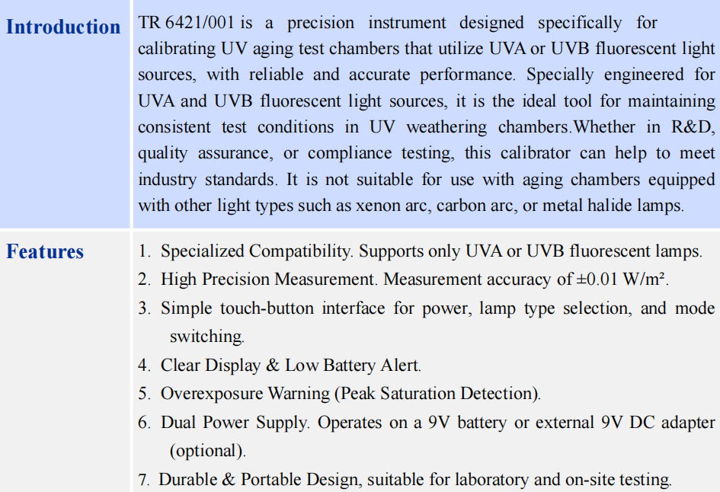

■ Parameters

Lamp type | UVA 340
Lamp type | UVB 313
Measuring range | 0 - 2.00 W/m2
Measuring accuracy | ±0.01W/m2
Resolution | 0.01W/m2
Electric Battery | 9V 6LR61
External power supply | DC 9V 0. 1A  (Power adapter must be purchased separately)
Working environment | Host: 10～40℃ , 0～85%RH
Working environment | Probe: 5～80℃ , 0～100%RH

